**What happened in the 1950s?**

**Lesson 8**

**By the end of this lesson, you should be able to:**

List the consequences of the Arab-Israeli War of 1948

Describe what happened in 1956

Explain how life differed for Palestinians and Israelis at this time

**Keywords**

Arab-Israeli War, 1948

David Ben-Gurion

Green Line

West Bank

Israel Defense Forces

Gamal Abdel Nasser

**Knowledge check!**

1)What was the Nakba?

2)What were the consequences of the Nakba for the Palestinians?

3)What do you know about the Cold War?

**The changing map of Palestine-Israel**

How many differences can you spot between these maps? Write them all down.

Map 1: *UN Partition Plan, November 1947*

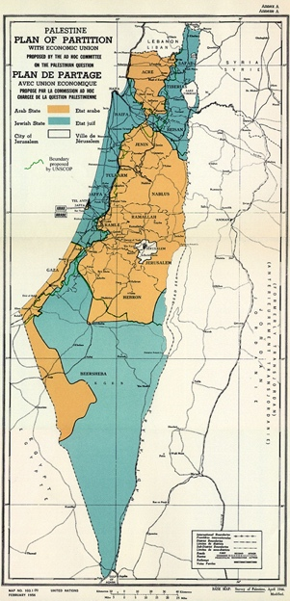

Map 2: *The new borders after the 1948 Arab-Israeli War*

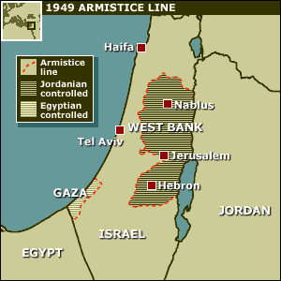

The term ‘West Bank’ was used because this part of Palestine-Israel was now part of the **West** Bank of Jordan!

**The consequences of 1948**

The Arab-Israeli War of 1948 had important consequences for Palestine-Israel. Most significantly, Israel now controlled 78% of the land of Mandate Palestine, which was much more than the proposed 55% under the UN Partition Plan of November 1947. Also, the remaining Palestinian areas were now controlled by the neighbouring Arab states of Jordan and Egypt. Jordan controlled an area that became known as the West Bank, and Egypt controlled Gaza

The new boundary between Israel and Gaza, the West Bank, Egypt, Jordan, Syria and Lebanon became known as the ‘Green Line’. This is because green was the colour of the ink that the line was drawn in on the original maps. Another consequence of the Arab-Israeli War was that the city of Jerusalem was divided into two parts: the eastern part was controlled by Jordan, and the western part was controlled by Israel

Many of these divisions still exist today

**Questions**

What was the most important consequence of the Arab-Israeli War of 1948? Why?

**Shifting borders**

Spend a few minutes examining Maps A-D below.

Answer these questions:

How are they different?

Why did these changes occur?

How would these changes make you feel if you were a) Palestinian b) Jewish?

**Map A - Palestine-Israel before WWI (pre-1918):**

**Map B - Palestine during the British Mandate (1918-1948):**

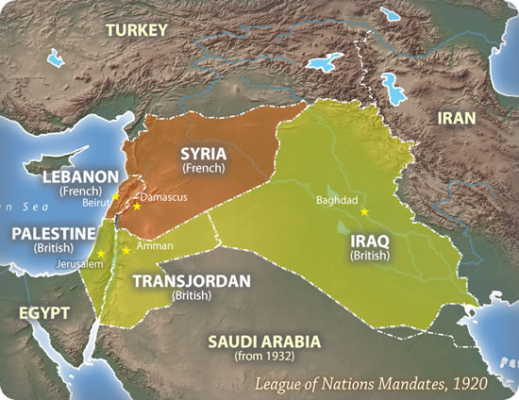

**Map C - UN Partition Plan in November 1947:**

**Map D - The new borders after the 1948 Arab-Israeli war:**



**David Ben-Gurion**

David Ben-Gurion was born in Poland in 1886. His father was an ardent Zionist, and in 1906 Ben-Gurion set off for Palestine-Israel. In his memoirs he explains that he left Poland not for ‘negative reasons’ of fleeing antisemitism, but for the ‘positive purpose’ of creating a Jewish state. In 1917, Ben-Gurion married and had three children

During the British Mandate, Ben-Gurion called for accelerated Jewish immigration to Palestine-Israel, and in the 1920s he became an increasingly influential member of the Yishuv (the Jewish community in pre-1948 Palestine-Israel). In 1935 he was elected chairman of the Zionist Executive and Head of the Jewish Agency

In 1948, Ben-Gurion became the **first Prime Minister of Israel**. He continued to lead the new state from 1948 until 1963, with a short break between 1954 and 1955. He left office in 1963 and retired from politics in 1970. He passed away in 1973

**Activity**

Create a short profile of David Ben-Gurion using this information

**The Law of Return**

The 1950 Law of Return stated that any Jew in the world had the right to travel to Israel and become an Israeli citizen. This meant that by 1951 the population of Israel had **doubled** to over 1.3 million people. This map shows Jewish immigration between 1948 and 1950

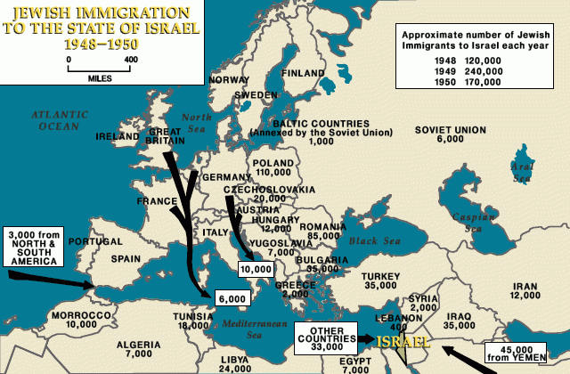

**Where did Palestinians live between 1948 and 1967?**

**The situation for Palestinians**

Meanwhile, hundreds of thousands of Palestinians were still miles from home. The Nakba had made 750,000 Palestinians refugees. In 1948, UN Resolution 194 stated that Palestinian refugees must be able to return to their homes or be financially compensated. But **nothing was done!**

Palestinians were now spread across Palestine-Israel and the surrounding countries. The Palestinians within the new state of Israel’s borders were placed under military law. Palestinians in the West Bank were under Jordanian authority. And the 200,000 Palestinian refugees who found themselves in Gaza were under Egyptian authority. Other Palestinian refugees were spread across 55 massive tented refugee camps in Jordan, Lebanon and Syria. In 1949, UNWRA had been established to help with these camps

1948 until 1967 was a very **difficult time for Palestinians**. Another 69 Palestinians were killed by Israeli forces in Qibya in the West Bank in 1953, and an attack on Palestinians in Al-Sammou in the West Bank in 1963 led to the UN condemning Israel for "violating the United Nations Charter and the General Armistice Agreement"

**The context of the Cold War**

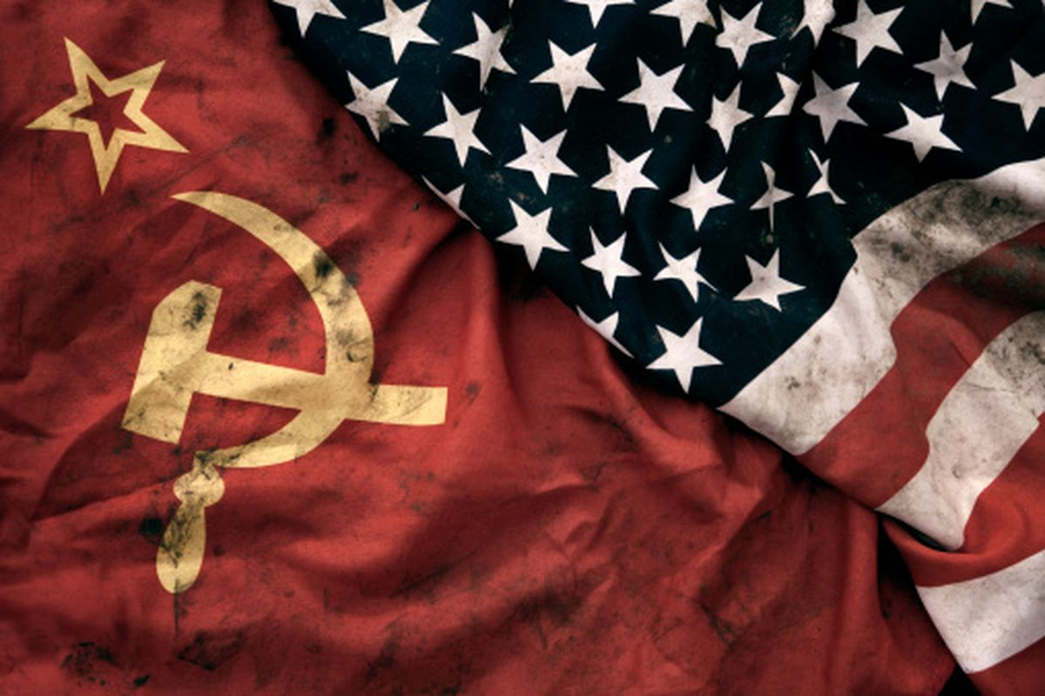

There was also tension between countries between 1948 and 1967 due to the Cold War

This was a time of **intense** **rivalry** between the **USSR** and western countries(particularly the **USA**). It started in the 1940s as the USSR and USA emerged as the new **superpowers** after WW2. The tension lasted until 1991

The rivalry between these superpowers was about ways of ruling: **communism vs. capitalism**. Communism is about **everyone** owning the means of production and there being no money or social classes. In contrast, capitalism is about **individuals** owning the means of production and making their own money. The USSR and USA believed in very different approaches to life

Key events of the Cold War include the 1956 Suez Crisis, the Korean War and the Cuban Missile Crisis of 1962. The war is known as ‘cold’ because it never got ‘hot’. There was never *direct* military action between the USSR and the USA. However, **this doesn’t mean that it wasn’t violent:** many individuals died in the ‘proxy’ wars that took place as a result of this rivalry and tension. A ‘proxy’ war is an armed conflict between two parties on behalf of others. The main example of this was the Korean War which took place between 1950 and 1953, with South Korea representing the USA and North Korea representing the USSR. Between 2 and 3 million people died in this proxy war

**Gamal Abdel Nasser**

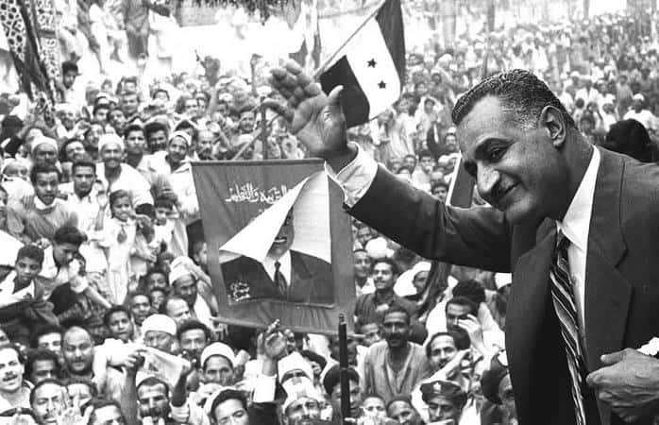

Gamal Abdel Nasser was born in Alexandria, Egypt in 1918. His father was a postal worker, which meant that he moved around a lot during his childhood. When he was at secondary school Nasser became involved in an Egyptian nationalist political party. In 1935, Nasser led a student demonstration against British rule

After school, Nasser focused on his military career. His first battlefield experience was during the Arab-Israeli War of 1948. Then, in 1952, Nasser led the 23 July Revolution, which overthrew the monarchy in Egypt and led to huge political, economic and social change. He was formally elected President of Egypt in 1956 and remained in this post until his death in 1970

**Activity**

Create a short profile of Gamal Abdel Nasser using this information

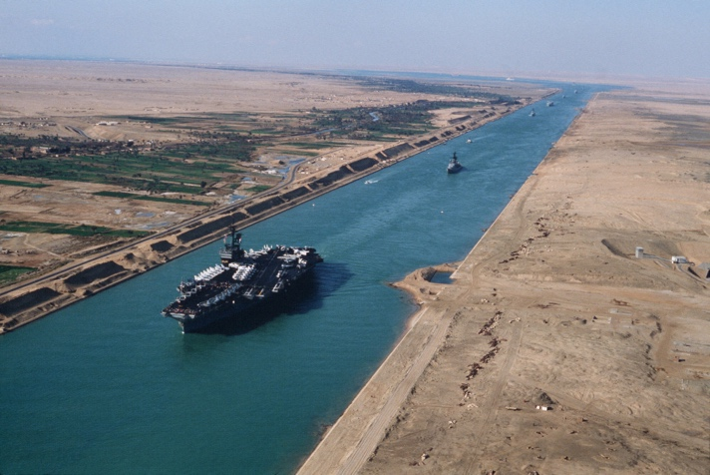**The Suez Canal**

The Suez Canal is an artificial waterway connecting the Mediterranean Sea and the Red Sea. It took ten years to build and opened in 1869. The creation of the canal means that ships do not need to travel all the way around Africa. In the 1950s, this meant that journey times were reduced by two weeks!

**The Suez Crisis of 1956**

Since the nineteenth century, there had been growing anti-colonial, nationalist feeling in Egypt. In 1922, Egypt had gained its independence from the British. However, the British had kept control of the Suez Canal. On 26 July 1956, Nasser nationalised the canal. He took it from British and French control and into Egyptian control

Britain and France were not happy about this. Israel was also worried by Nasser’s popularity in the Arab world because there was growing support at this time for Arab nationalism: a political movement to unite Arabs. Nasser was seen as the leader of this movement

On 29 October 1956, war broke out between **Israel, Egypt, Britain and France.** However, pressure from the USA and USSR meant that fighting stopped after just a week. Britain and France were forced to stand down. This was an **embarrassment** that some say signified the end of Britain’s role as a major global power. This is also known as the second Arab-Israeli War. Egyptians call it the **Tripartite Aggression**

**Check your knowledge**

1)Using Map D from 1949 to help you, list three consequences of the Arab-Israeli War of 1948

2)Where did Palestinians live in the 1950s?

**Extension activity**

To help you remember what happened to the Palestinians in 1947 and after, write a series of diary entries from the point of view of a Palestinian